Adaptive Multi-Cell Battery Intelligence Engine
Internship Task | ElevanceSkills
Student Name: Poorwaksha Panse
Date: 29 May 2026

- Objective
Implement a production-grade battery intelligence engine capable of monitoring a simulated 4-cell lithium battery pack in real time using Arduino Uno on the Wokwi platform.

2. System Architecture
The system uses 5 modular software components:
- Module 1: ADC reading with 8x oversampling for noise reduction
- Module 2: Voltage calculation using the voltage divider formula
- Module 3: Pack statistics (average, total, imbalance %)
- Module 4: Health classification state machine
- Module 5: Formatted serial monitor output

3. Circuit Design
Each of the 4 cells is simulated by a potentiometer. The output voltage is scaled using a resistor divider (R1 = 100kΩ, R2 = 33kΩ) so a 4.2V cell maps to ≈1.04V, safely within the Arduino's 5V ADC range. All 4 divider outputs connect to pins A0–A3.
4. Health Classification Logic
State | Condition
Healthy | Imbalance < 2%
Minor Imbalance | 2% ≤ imbalance < 5%
Critical Imbalance | imbalance ≥ 5%
Pack Failure | Any cell < 3.0V or > 4.3V

5. Results
The system successfully identifies the weakest and strongest cells, calculates State of Charge (SoC) per cell, and prints a complete diagnostic report every 2 seconds over the serial monitor.
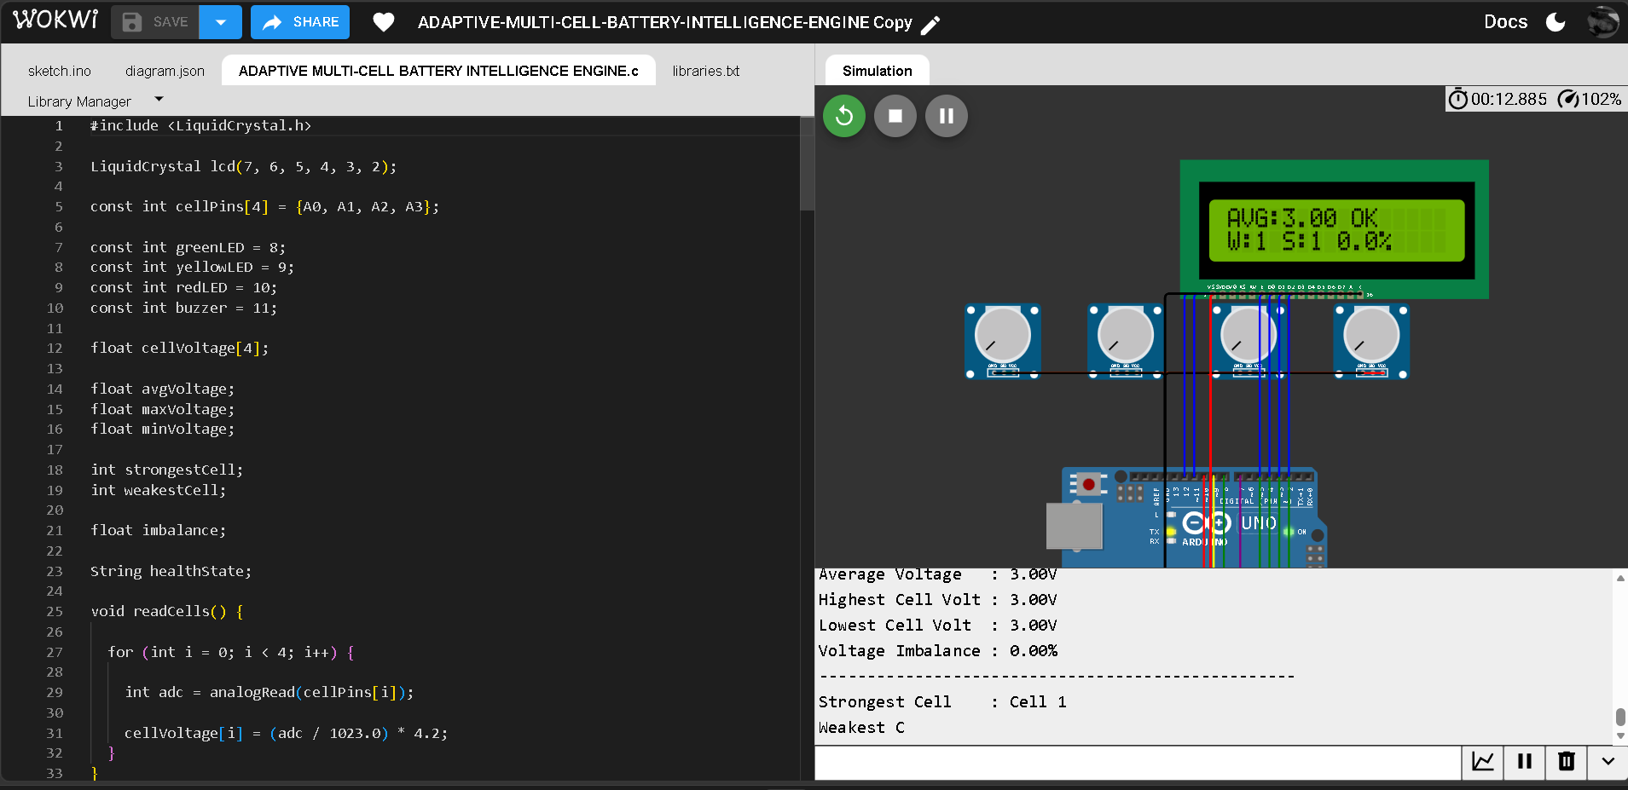

6. Live Simulation Link [ADAPTIVE-MULTI-CELL-BATTERY-INTELLIGENCE-ENGINE Copy - Wokwi ESP32, STM32, Arduino Simulator]

7. GitHub Repository [Poorwaksha/ADAPTIVE-MULTI-CELL-BATTERY-INTELLIGENCE-ENGINE: Production-grade 4-cell Lithium-ion Battery Management System (BMS) simulation using Arduino UNO in Wokwi with real-time voltage monitoring, battery health analysis, imbalance detection, LCD dashboard, LED alerts, buzzer warning system, and modular embedded architecture.]

